Temperature: How does your Body Control Itself?
---------------------------------------------------------------------------------------------------
Collin McGarty, Tyler Nettleman, Roland Deal, Sage Jones
STEM Marin, San Marin High School, Novato, California 94947
---------------------------------------------------------------------------------------------------------------------

Introduction

We have to constantly lose heat to maintain our normal temperature in our bodies. When it is hot outside, our bodies increase blood flow to our skin so we can cool down faster. Allowing our bodies to heat up is an example of hypothalamus. Hypothalamus helps regulate the temperature in our bodies. We decided to begin this experiment by running around the track to increase our overall body temperature. After sprinting one lap we put the thermometer in our group members armpit and gave it some time before concluding our results.

Abstract

Objective- Testing homeostasis in our bodies through body temperature before physical activity, right after, and after 5 minutes after.
Design- Run 1 lap and take temperature before, right after, and 5 minutes after.
Subjects- This experiment consisted of 1 boy enrolled in high school.
Variables Measured- The variables measured were the weather conditions and how fast the person was running
Analysis- Our experiment was testing homeostasis in human body temperature. To test this we went outside onto the track and had took the temperature before running, then we had one person (control) run 1 hard lap. Immediately after running the lap, we used a thermometer to take the person's temperature to see if it increased. Then we waited 5 minutes and took the temperature again to see if the temperature returned to normal. We repeated these steps in different weather conditions. (sunny & cloudy)
Results- Temperature was 32 degrees celsius before running, went up to 34 degrees celsius after. After a five minute cooldown the temperature went back down to 31 degrees. Temperature outside was about 13 degrees celsius.
Implications- These findings suggest that after physical activity our body temperature increases. But, because of homeostasis it returns to normal after a cooldown period.

Procedure + Materials

1. Record outside Temperature (in celsius)
2. Take your body temperature, while standing outside.
3. Run two laps around the football field.
4. Take your body temperature directly after running the two laps around the football field.Place a thermometer under your armpit and record the body temperature
5. Wait five minutes. Record anything that happens to your body (shivering, sweating, etc.)
6. Take your temperature again, after waiting
7. Repeat steps 1-6 for further investigation what does this mean

Materials List
Thermometer
Timer

Results

Before running, we took the body temperature of one of our subjects, which turned out to be 32 degrees celsius. Then, we went outside to the football field and the same person ran two laps around the field. We then took the same person’s temperature, which raised to 34 degrees celsius. Then, we waited five minutes for the body to take over and let their body temperature even itself out. During this time, the person was breathing heavier as well as working up a light sweat. After waiting, the body temperature lowered back down to 32 degrees celsius. We tested this two more times and the results stayed the same each time.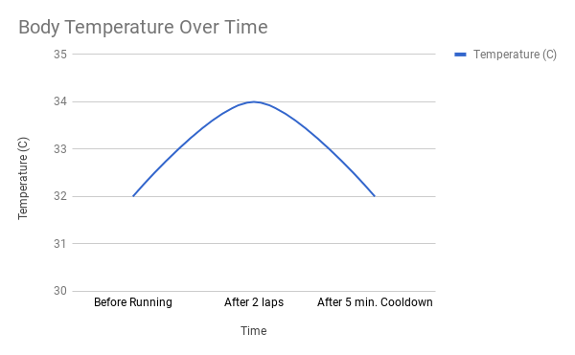
Discussion
During this project, our group discovered that our body temperature rises from exercise. We found that our body’s starting temperature rises 2 degrees celsius after about 2 minutes of exercise. We were able to find a consistent rise in body temperature at a rate of 1 degree per minute. Some problems that we ran into included not being able to find someone to run. We chose a cold day to get our data and no one in our group wanted to run. Some improvements that we could have made would be using the thermometer correctly instead of just putting it in our armpits. This would give us a more accurate measurement. We could further investigate this by doing the same test on a hot day to see if that further changes our body temperature.

