Cheese Lab Write Up Tyler Nettelman
STEM 1 period
11/7/17

Purpose:

The purpose of this lab was to find the most efficient way to make cheese. This lab was divided into 3 sections.
In the first section we tested curdling agents to see which one worked best to make cheese from milk. The four agents we added to the milk base were water, Chymosin (FPC), Buttermilk, and Chymosin (NCB). To determine which one worked best, we looked at the time it took to make cheese and how much cheese was created.
In the second section we needed to change one variable (Chymosin(FPC) agent amounts) from our first experiment and see how it altered the rate of curd production.
In the third section we tested the cheese we had previously created to see if it contained Monosaccharide (sugar), starch, protein, and lipids (fats).

Hypothesis:

Part 1: If creating cheese from milk using water, Chymosin (FPC), Buttermilk, and Chymosin (NCB), then Chymosin (FPC) will create the most rapid curdling.

Part 2: If more Chymosin (FPC) is used, then more curds will be produced even quicker than when using the standard amount of (FPC).

Part 3: If the cheese we create is tested for sugar, starch, protein and fat, then they will all be found in the cheese.

Procedure:
In accordance to Biotechnology: Science for the New Millennium by Ellyn Daugherty

Part 1:

- Label four 6ml tubes with the type of curdling agent and group number.
- Use a large pipet to transfer 3 ml of milk into each of the 6ml tubes.
- Use a small pipet and transfer the entire contents of the tubes of fermentation produced chymosin, natural bovine chymosin or buttermilk to the labeled tube containing the milk. For water, fill the small transfer pipet tube to the bottom of the bulb and add to the labeled tube containing the milk. Use a different pipet for each transfer to avoid cross contamination.
- Cap the tubes and invert the tubes three times and then transfer to 37 C water bath or place at body temperature for incubation.
- Set a timer and check for curdling every 5 minutes, by gently inverting the tube and examining for curds.
- Record the time (mins) when the milk begins to curdle.
- If the milk doesn't curdle in 30 minutes, check for curdling every hour.
- In a data table similar to Data Table 1, record the time when the milk begins to curdle.
- Upon return to the lab, during the next work period, determine the amount of curds produced by each treatment.
- For each treatment, weigh a paper cone and record the empty cone weight.
- Transfer the entire contents of the tube onto a labeled filter paper cone over a collection vessel. Once all liquid has drained through, dry the filter paper with the curds overnight.
- Weigh the dry cone with the dry curds. Subtract dry cone weight. Record the weight of the curds in mg by multiplying the weight in grams x 1,000.
- Repeat with each treatment.
- Create a data table that reports the rate of curd production (weight/time) by each curdling agent.
- Create a bar graph that shows the rate of curd production.

Part 2:

- Lable two 6ml tubes with the amount of FPC chymosin agent (3x and 1x)
- Use a large pipet to transfer 3 ml of milk into each 6ml tube
- Use a small pipet to transfer the different amounts of FPC into each labeled tube.
- Cap and invert the tubes three times and then transfer to 37 C water bath or place at body temperature.
- Set a timer and check for curdling every five minutes.
- Record the time in minutes when the milk begins to curdle.
- In a data table, record the time in minutes when the milk begins to curdle.
- Upon return to the lab, during the next work period, determine the amount of curds produced by each treatment.
- For each treatment, weigh a paper cone and record the empty cone weight.
- Transfer the entire contents of the tube onto a labeled filter paper cone over a collection vessel. Once all liquid has drained through, dry the filter paper with the curds overnight.
- Weigh the dry cone with the dry curds. Subtract dry cone weight. Record the weight of the curds in mg by multiplying the weight in grams x 1,000.
- Repeat with each treatment.
- Create a data table that reports the rate of curd production (weight/time) by each curdling agent.
- Create a bar graph that shows the rate of curd production.

Part 3:

- Monosaccharide Indicator Test
  - Test for glucose. In a test tube, mix 2 ml of a 2% glucose solution with 2 ml of Benedict’s solution. Heat for 2 minutes in a boiling hot water bath (100 ml of water in a 250 ml beaker at 100 C) Record all color changes and the length of time for each color to appear.
  - Test for negative control. In a test tube, mix 2 ml of deionized water with 2 ml of Benedict’s solution. Heat for 2 minutes in a boiling hot water bath (100 ml of water in a 250 ml beaker at 100 C) Record all color changes and the length of time for each color to appear.
  - Test for cheese. In a test tube, mix crushed up cheese powder with 2 ml of Benedict’s solution. Heat for 2 minutes in a boiling hot water bath (100 ml of water in a 250 ml beaker at 100 C) Record all color changes and the length of time for each color to appear.
- Starch Indicator Test
  - Test for starch. In a test tube, mix 2 ml of well mixed starch suspension with 0.25 ml of Lugol’s iodine. Gently swirl to mix. DO NOT HEAT. Record the color change.
  - Test for negative control. In a test tube, mix 2 ml of deionized water with 0.25 ml of Lugol’s iodine. Gently swirl to mix. DO NOT HEAT. Record the color change.
  - Test for cheese. In a test tube, mix crushed up cheese powder with 0.25 ml of Lugol’s iodine. Gently swirl to mix. DO NOT HEAT. Record the color change.
- Protein Indicator Test (CAUTION: Sodium hydroxide is a strong base, is caustic, and can burn)
  - Test for protein. In a test tube, mix 2 ml of gelatin (protein) solution with 0.75 ml of Biuret reagent. Record color change.
  - Test for negative control. In a test tube, mix 2 ml of deionized water with 0.75 ml of Biuret reagent. Record color change.
  - Test for cheese. In a test tube, mix crushed up cheese powder with 0.75 ml of Biuret reagent. Record color change.
- Lipid Indicator Test
  - Test for Lipids. Place a drop of oil (100% fat) on a piece of brown paper bag. Let it “dry” for 10 minutes. Hold up paper to light. Record how much light passes through the spot (% of translucence).
  - Test for negative control. Place a drop of water on a piece of brown paper bag. Let it “dry” for 10 minutes. Hold up paper to light. Record how much light passes through the spot (% of translucence).
  - Test for cheese. Place a drop of water containing suspended cheese powder on a piece of brown paper bag. Let it “dry” for 10 minutes. Hold up paper to light. Record how much light passes through the spot (% of translucence).
  - Test for cheese. Mix 60 μl of Sudan IV solution into 2 ml of water containing the crushed up cheese powder. Red color means negative while an orange color means a positive for lipids.

Data/ Observations:

Below are two different pieces of data we collected during the first part of this lab. Table 1 represents all of our recorded data discovered in the first portion of the lab and Table 2 is our data discovered in the second part of our lab. In Table 1 we show which type of curdling agents were used to make cheese, how long it took (minutes), the weight of dry curds, the weight of the dry cheese curds before being separated from the whey, and the rate of production (weight/time). In Table 2 we recorded the same information, but used varying amounts of Chymosin (FPC) as our curdling agent.

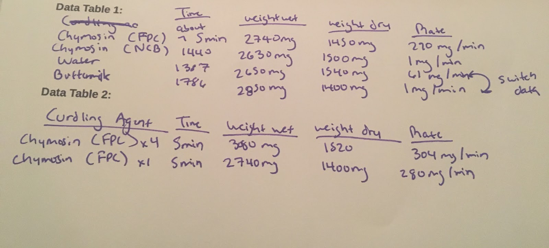

Below is a graph which compared the rates of curd production for the four agents we tested. (FPC) has a significantly higher rate of production compared to the other 3 agents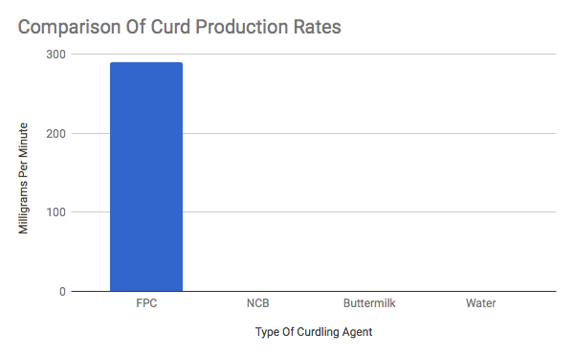.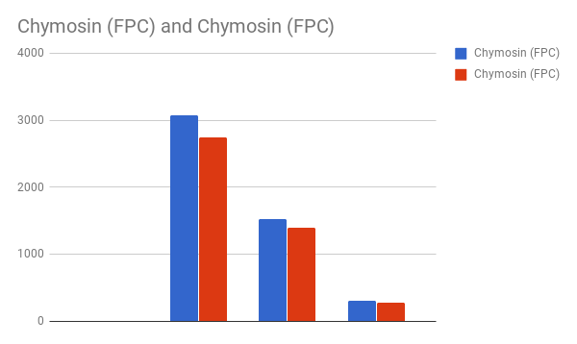
In this comparison of (FPC), the blue bar indicates Chymosin (FPC) x4 and the red bar indicates Chymosin (FPC) x1.

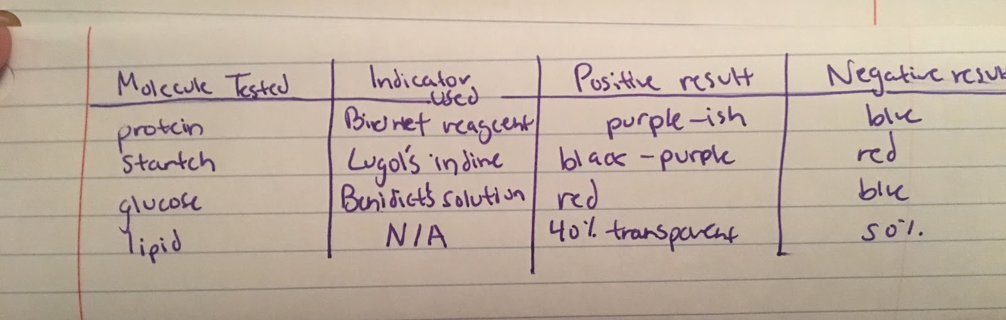

Observations during this lab were that all of the agents except water had distinct, unpleasant smells. Buttermilk took almost two days to curdle, while (FPC) and (NCB) only took a day. The tube with the water curdled the least and took about 3 days. When they curdled, the color became more yellowish. When we strained the cheese through the cheesecloth, the cheese appeared sticky and clumpy.

Analysis:

Part 1:

According to the data in Table 1, Chymosin (FPC) was the agent that curdled cheese the fastest and produced the most cheese. It was significantly better than water, (FPC) and buttermilk (see Graph 1). This proves that the hypothesis is correct that if creating cheese from milk using water, Chymosin (FPC), Buttermilk, and Chymosin (NCB), then Chymosin (FPC) will create the most rapid curdling. Errors that could have occurred were that we could have miscalculated the weight wet, which would have then made the weight dry incorrect and caused us to think we had more or less cheese production. Another error that could have happened is that we could have mixed up the curdling agents, specifically (FPC) and (NCB) as they looked so similar, and entered them into the wrong columns of the table. We also could have mismeasured the amount of agents as we used the pipette to transfer them into the milk, and an inaccurate amount would have then slowed down or sped up the rate of curdling. This experiment could be expanded to test a wider range of curdling agents. It also might be interesting to test how the cheese created with different agents tastes, and if people agree on the best and worst tasting cheeses.

Part 2:

According to the data in Table 2, when (FPC) is used as the curdling agent at 4x the normal rate, more curdling occurs at a higher rate. This can also be observed in the comparison graph, as the blue bar (FPC x4) is higher than the red bar (FPC x1). The dry weight of (FPC) x4 was 1520 mg compared to 1400 mg with (FPC) x1. The rate for (FPC) x4 was 304 mg/min compared to 280 mg/min for (FPC) x1. Therefore, the hypothesis that if more Chymosin(FPC) is used, then more curds will be produced even quicker than when using the standard amount of (FPC). Errors that could have occurred in Part 2 were miscalculating the amount of additional (FPC), which would have resulted in more or less curd production, thereby throwing off the data. Another possible error could have been contamination with the pipette tips as we opened the bags. Foreign bacteria could adversely affect the production of cheese. This part of the experiment could have been expanded by adding additional amounts of (FPC). For instance, x1, x4, x8, x12 to see if there was a consistent rate of increased curd production and rate.

Part 3:

The table containing our data from part three shows what each of the tests will look like if the substance contains each molecule. This shows which of the four molecules were tested on the cheese we created. According to the data, all cheese contains fats, proteins, and glucose, but not starch. My hypothesis that if the cheese we create is tested for sugar, starch, protein and fat, then they will all be found in the cheese was proven incorrect. Some errors that could have affected the process would be using the solution containing the molecule and water mixed with crushed cheese powder instead of using the indicator and the water with crushed cheese powder proving the results inaccurate. Another error would be to just use bigger flakes of cheese mixed into the indicator because this could have made it difficult for the two to interact with each other, as by crushing the cheese and drowning it in water allows the it to mix with the other indicator solution. Because of this particular experiment we will be able to dig further into the question of if different cheeses contain different molecules.

Conclusion:
The curdling agent used to make cheese is an important aspect of the process. We tested 4 curdling agents in milk, recorded our data, and determined the amount of cheese produced as well as the curdling rate. We tested how adjusting the amount of fermentation-produced chymosin, or (FPC) would affect curdling. This genetically engineered agent speeds the production of curdling as well as the amount of cheese produced. Finally the cheese created was tested for sugar, starch, protein and fat and was found to have all but starch in it.

